CS 577: Project 4: Traveling Salesperson Tours

Date set:
I generate 6 different kinds of data sets and compare the output of each sets --- the path lengths, and get the conclusion.

- Point 1: points in the homework : [(1, 7), (2, 0), (3, 4), (6, 5), (7, 2), (8, 6), (10, 4)]
2 different approximation algorithms create the same path with same path length: 27.8941079323.
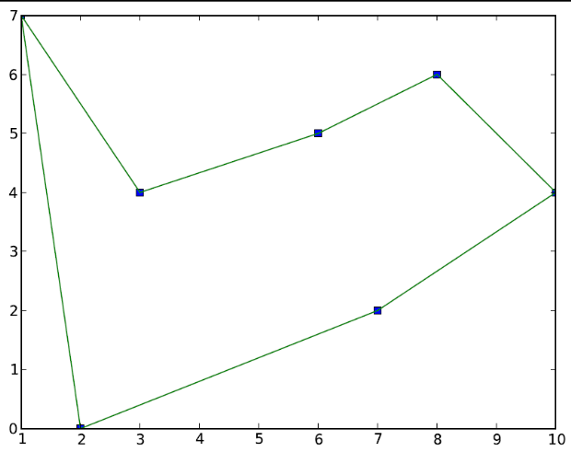
- Point 2: I uses UniformRandomPoints generate random points
We take 5 experience with 30 random points between -5 < x < 5 and -5 < x < 5
MST: path length = 60.0972868481 Bitonic tour: path length = 63.6033894792
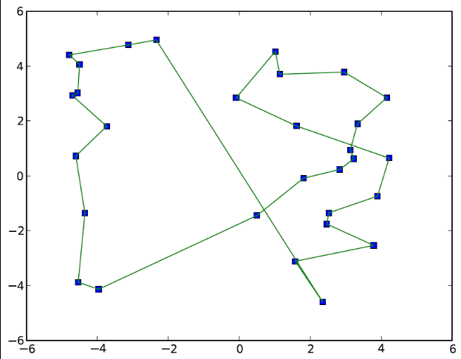
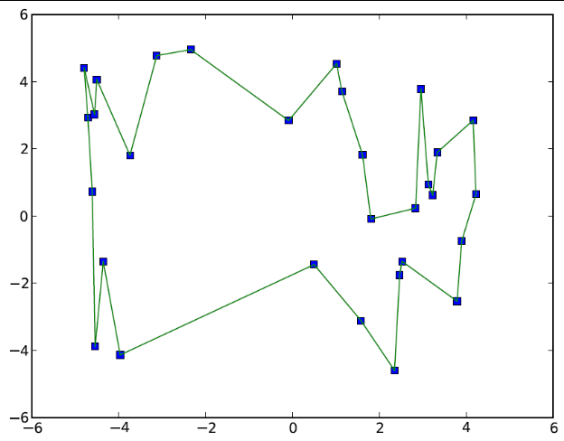

Conclusion: from the figure and the output of the path lengths, I try 5 experience with different points generated by the UniformRandomPoints function in my code, and always get the result the path length of MST is smaller than Bitonic tour.

- Point 3: GaussRandomPoints generate random points
We generate 30 random points betweem -0 < x <2 amd -0 < y <2
MST: path length = 44.5623105301 Bitonic tour: path length = 44.5861414478

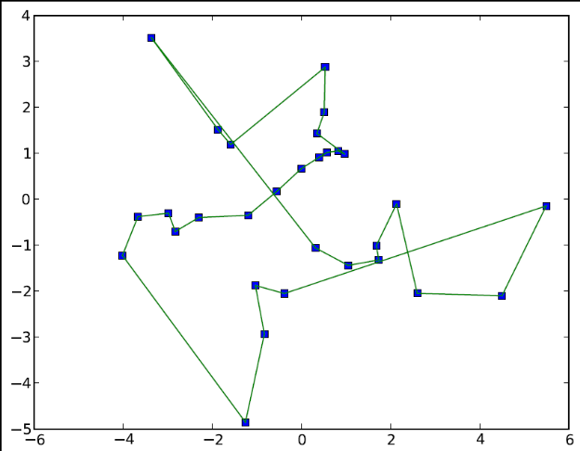
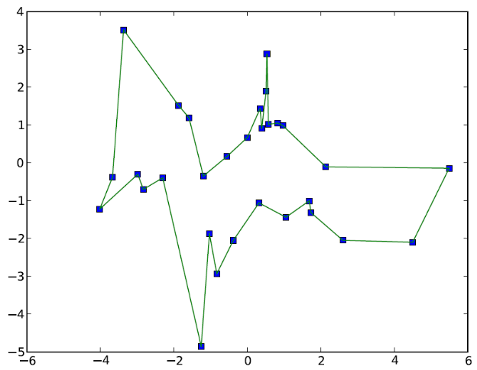

Conclusion: from the figure and the output of the path lengths, I try 5 experience with different points generated by the GaussRandomPoints function in my code, this generator generates point more tightly than UniformRandomPoints function. This time, I get result that the path length of MST and Bitonic tour almost the same by several experience.

- Point 4: CirclePoints generate random points
We generate 30 points which makes a whole circle at the end by ratio is 5.
2 different approximation algorithms create the same path with same path length = 31.3585389803
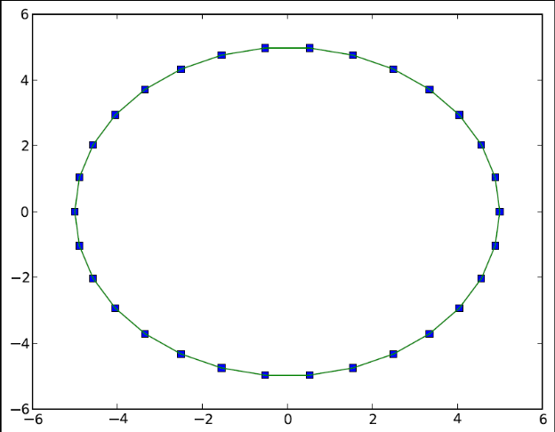
Conclusion: from the figure and the output of the path lengths, I try 5 experience with different points generated by the CirclePoints function in my code. I also try to generate a rectangle and a square, the result come the same as the circle.

- Point 5: CirclePointsWCenters
We generate 30 points which makes a whole circle at the end by ratio is 5, and uniformed random points within -1 < x < 1, -1 < y <1.
MST: path length = 46.9863851725 Bitonic tour: path length = 60.9776410967

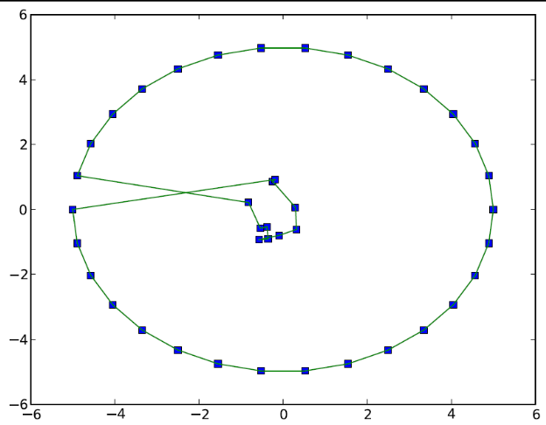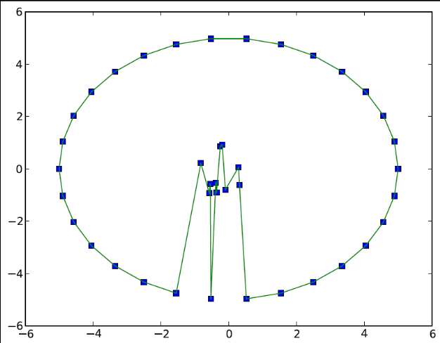
Conclusion: from the figure and the output of the path lengths, I try 5 experience with different points generated by the CirclePointsWCenters function in my code. I want to see how these two algorithms handle the points in the center. The result shows that using MST, we could almost always get the smaller path length.

- Points 6: SeveralUniformRandomParts
We generate 70 random points in total but partite in 7 small groups, each small group uniformed in a small area.
MST: path length = 137.053054117 Bitonic tour: path length = 127.558172596
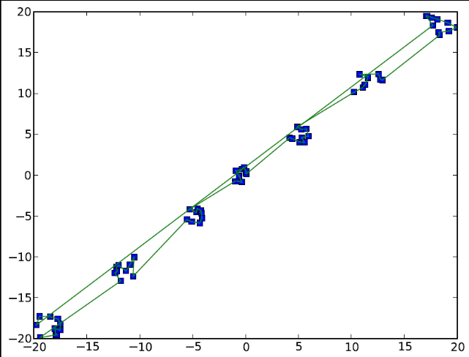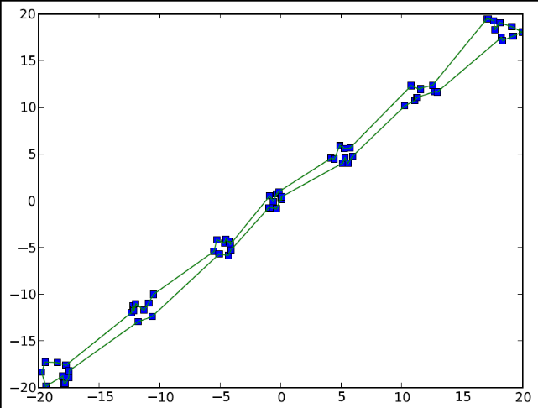
Conclusion: from the figure and the output of the path lengths, I try 5 experience with different points generated by the SeveralUniformRandomParts function in my code. I want to see how these two algorithms handle the points grouped in several small groups. The result shows that using Bitonic tour, we could almost always get the smaller path length. The reason is that using MST, we add in one point each time by the method in my code, so the nth point will be linked to the 1st point at the bottom of the left sight, which will have a relatively very long path compared with the others.

Approximation Algorithms:
From the 6 kinds of data sets I generated, we can analysis some of the advantages each algorithm has.
If points are all in the outer circle or very sparse, MST and Bitonic tour might have a same path length in most of the time.
For MST, if the points are mostly set on the outer circle but with some points in the center, the path length will be smaller.
For Bitonic tour, if points stay in many small groups and tight in each group, this algorithm will give us a small path length.
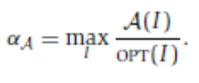where OPT(I) denote the minimum cost to dealing with a minimization problem, and A is an algorithm for a certain problem.
As the different kind of data sets we considered in this project, we could get the Approximation algorithms for each of them, which means MST and Bitonic tour are more suitable for some certain kinds of points.

